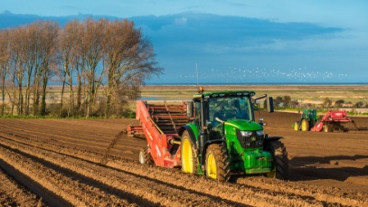 

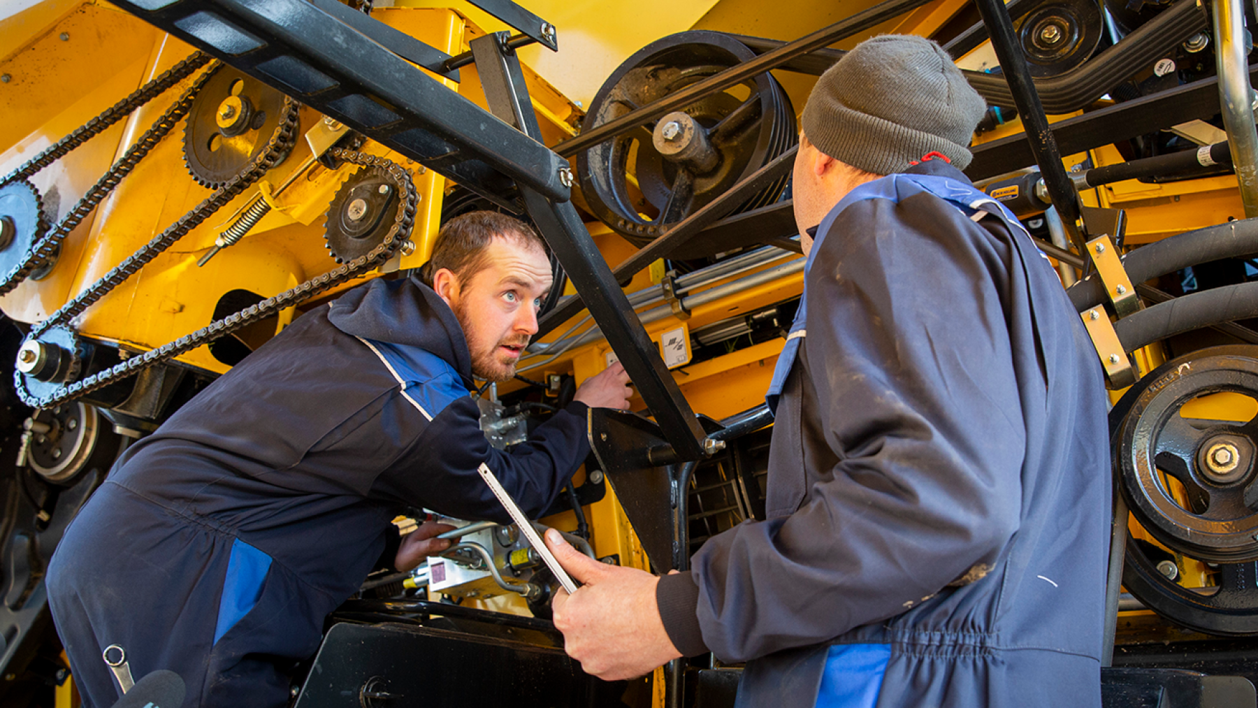

**Agricultural Technician Worksheet**

**Video Feedback**

Please list the video or videos you watched and write down the key points you learned

**NAME: DATE:**

1. What type of Agricultural Technician Career/s are you interested in? (You can put more than one)
2. What qualifications (GCSEs etc) do you need to go into a career as an Agricultural Technician?
3. Are you applying for: Sixth Form College Apprenticeship Not Sure

Put X in relevant box or boxes

1. What Skills do you think Agricultural Technicians need? Please list at least four:

1 2 3 4 4

1. What Agricultural Technicians jobs are available in your area?

(list two examples from www.indeed.co.uk):

Company Job Title Salary

Company Job Title Salary

1. Now, a task that will require some research:
2. Please list three websites where you can gain information regarding Agricultural Technician Careers

1

2

3

1. Where could you volunteer to get experience to support your career?
2. Please answer the following questions:

**Why do you want to work as an Agricultural Technician?**

**Why do you believe Agricultural Technicians are important?**

**What types of equipment do Agricultural Technicians use?**

**What are the Health and Safety issues working as an Agricultural Technician?**

**What Apprenticeship routes are available to become an Agricultural Technician?**

**What is meant by a Land-Based Agricultural Technician?**

**An Agricultural Technician can also have a science-based role. Please explain:**

**Can an Agricultural Technician help the environment in any positive way?**

**How do you feel about working outside in all weathers?**

**Please write a short essay explaining your route to become an Agricultural Technician:**

Where you are now?

Steps to get qualified?

What experience do you need?

Further research required?

**Are you considering any other careers?**

**If you have completed all sections, go back to the Main Menu to find the link to download and complete your certificate.**

**You will find that this worksheet forms part of the certificate, so don’t think you can just get one without doing the work.**

